The university of Azad Jammu and Kashmir ,
Muzaffarabad

Name | Adeela Bashir
Roll no | 2024-SE-12
Course Title | Computer Networking
Lab | 6
Submitted to | Dr Asma Javaid

Department of Software Engineering

Lab#4
Building connection between 2 LANs:
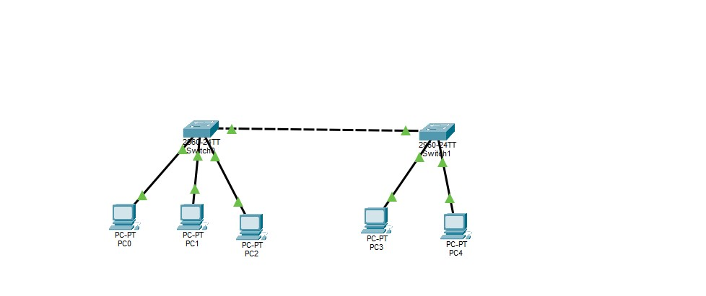
Assigning IP Addresses to PC’s:
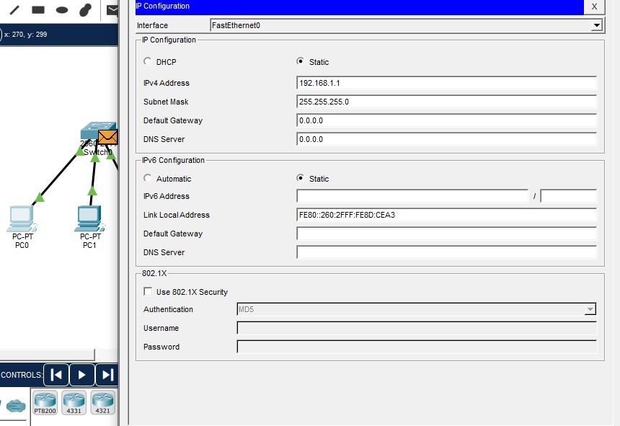

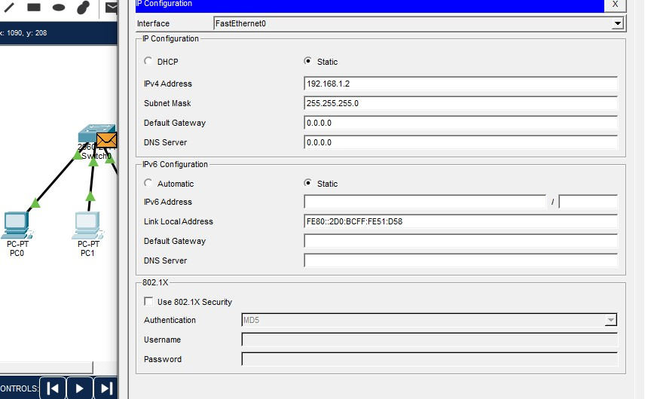

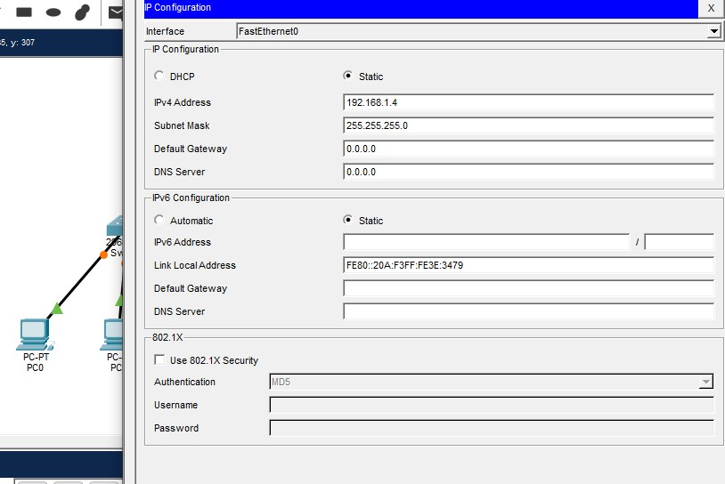

Simulation of packet between PC1 and PC3:

